Roll No.:- 48

Name:- KAWALE ROSHANI VASANT

Assignment No.:- 1.2

Assignment:- Develop program to learn different types of structures(list, dictionary, tuple, range, sting) in python

1. **For loop using range function.**

**for** x **in** range(7):  
 print(x)

**Output:-**

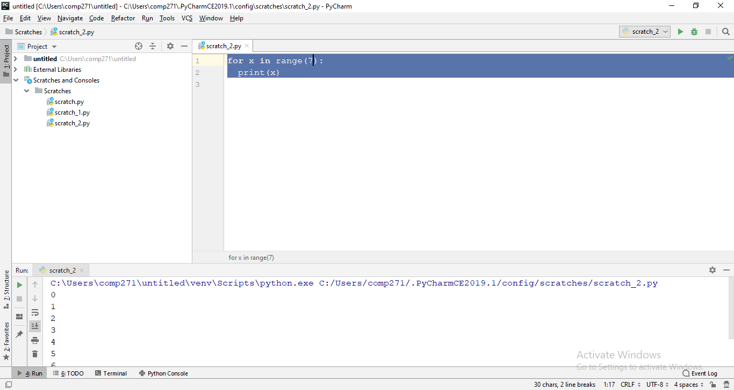

1. **For loop using string function.**

**for** x **in "Namrata Patil"**:  
 print(x)

**Output:-**

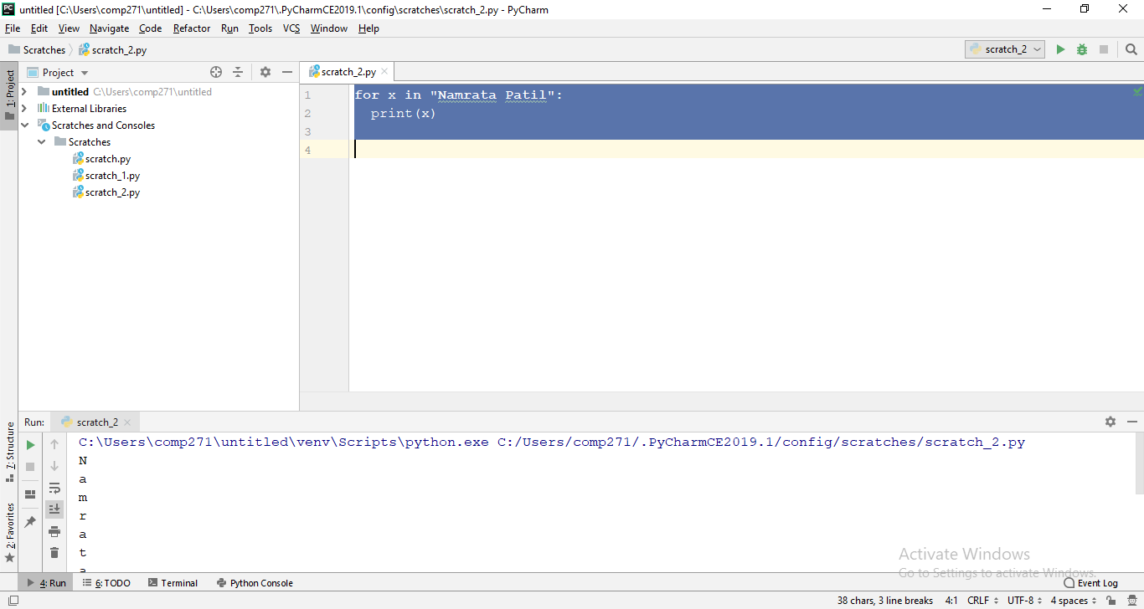

1. **For loop using list function.**

flowers = ("Rose", "Lily", "Lotus")  
for i in range(len(flowers)):  
 print(flowers[i])

**Output:-**

